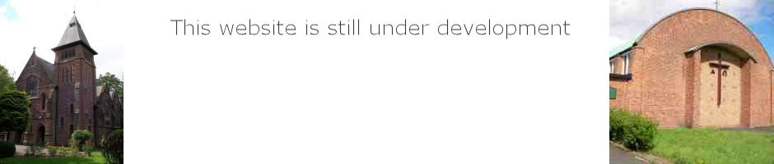
St Paul’s & St Timothy’s Parish
Can you help? Your parish needs you

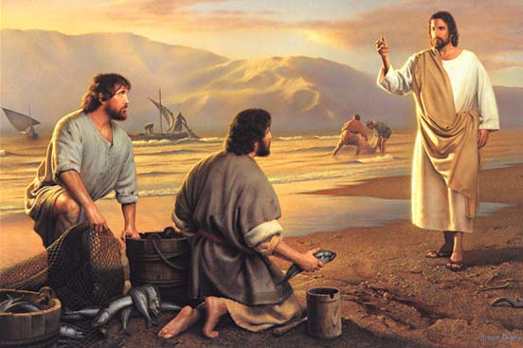

Dear Sisters and Brothers
We are greatly blessed with volunteers here at St Paul’s and St. Timothy’s, and we want to take some time to celebrate and appreciate those who volunteer their time and talents. While we recognise our ultimate reward is in heaven and what little we can do here on earth hardly compares to that reward, we believe it’s ok to simply say “thank you”, and keep up the good work. We are always in need of more volunteers in helping to build up and sustain our parish. Therefore I am making an appeal for people to consider how they might be able to use your gifts and talents in building up and sustaining our parish. Please take some time to consider volunteering for one or more of the activities overleaf.
Prayers and best wishes Fr. Darren

If you are going to fill in your details on next 2 pages, then consider saving in a different file and then deleting the first page before sending form to the presbytery. Details of how to send are on the last page.

Parish of St Paul & St Timothy
10 Spring Grove, LIVERPOOL, L12 8SJ
Volunteer Form
Please consider volunteering for one or more of the activities listed below.
- Collection counters and bank preparation (Sunday)
- Weekly health and safety checks/ fire alarm checks. Both churches, presbytery and Bonsall Centre
- Building maintenance both churches, presbytery and Bonsall Centre
- Grounds maintenance both churches and St Paul’s presbytery
- Odd jobs both churches St Paul’s presbytery and Bonsall Centre
- Sacramental programmes Baptism First Holy Communion Marriage Confirmation (Training would be provided). Tick the relevant box or boxes
- Reader at Mass
- Eucharistic Minister at Mass both churches
- Social events
- Church cleaning
- Preparation of rotas for volunteers
- Choir for 8:30am Mass St Paul’s
- Fund raising
- Youth
The above list will not have covered every activity in the parish, so if there is something that you would like to be involved in please write a brief description below.
……………………………………………………………………………………………………………………………………………………
……………………………………………………………………………………………………………………………………………………

Volunteer information sheet
Please fill in all sections of form and put N/A if that section is not applicable.
Name………………………………………………………………….

Church you attend……………………………………………………

Address……………………………………………………………….

…………………………………………………………………………

Post Code………………………………

Telephone No………………………………………………………...

Mobile…………………………………………………………………

Email…………………………………………………………………..

Some of the activities in the parish will require a DBS certificate.
If you require any further information do not hesitate to contact me frdarrensspaulandtimothyparish@gmail.com or call 0151 228 3405
You can post a paper copy of the form or deliver it by hand or email the document to
officesspaulandtimothyparish@gmail.com

